|  |
| --- |
| Martin Rule, Lane Cotgrove, James Bayliss |
| Motion Project |
| Kinect client user guide |

|  |
| --- |
| Martin Rule  9/19/2012 |

Table of Contents

1. Introduction 2

2. Requirements 2

3. Set up 3

3.1 Kinect device 3

3.2 Kinect device drivers 3

3.3 Kinect software development kit 3

4. Installation 3

5. First time use 4

5.1 Color View 4

5.2 Skeletal view 5

5.3 Server interface 5

5.4 Kinect interface 6

5.5 Event log 6

## 1. Introduction

The Kinect Client developed for Sensing Places is a program developed to capture movement data from a Kinect device via the Kinect SDK and transmit that information to a local or remote server. For a technical description of how this is done please refer to the development documentation.

This guide will provide information on the set up and operation of this program.

## 2. Requirements

This application was developed on x84 and x64 based Windows 7 systems. Some issues may be experienced with other windows systems (Windows XP etc). Currently there is no support for Linux or IOS based systems.

Memory: 1GB+  
Processor: 2.2Ghz Dual Core+  
Operating system: X84 or X64 Windows  
Network: High speed broadband connection

## 3. Set up

Before installation

There are three things you will need before the program can operate successfully. If you already have one or more of these requirements please check they are updated to the newest version.

## 3.1 Kinect device

You will need one Kinect device attached via USB to your system. The purpose of this device is to capture the movement data being handled by this program.

## 3.2 Kinect device drivers

These are used to facilitate all interactions between the previously connected Kinect device and your system. There are two ways these can be installed. If using an operating system such as Windows 7 these drivers should install automatically. However if this does not happen these drivers can be downloaded and installed from the official Microsoft Kinect website.

## 3.3 Kinect software development kit

This is an essential part needed for the operation of this system. It contains many components used through the Kinect client system. This can be downloaded from the official Microsoft Kinect website

## 4. Installation

The application is a standalone executable that requires no specific installation. You may however need administrator rights for this system to work correctly.

## 5. First time use

When you first start the application you will be presented with this user interface

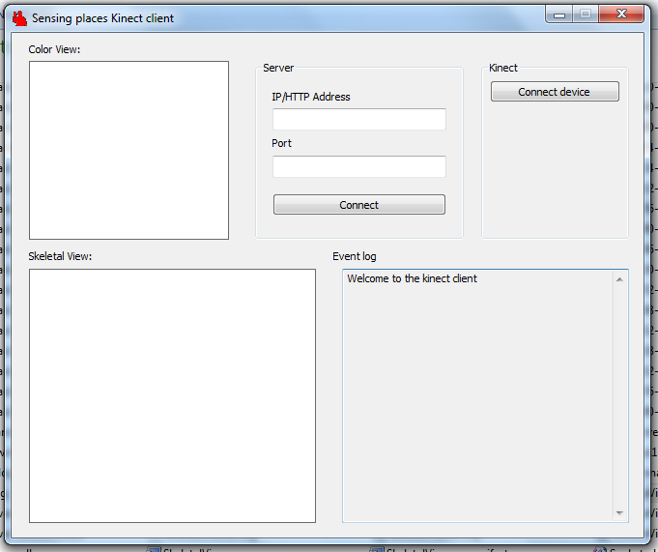

There are five main sections to this interface

## 5.1 Color View



This window will show a raw what the Kinect is currently looking at. This is useful for making sure the device is oriented correctly and that the device is currently working correctly.

## 5.2 Skeletal view

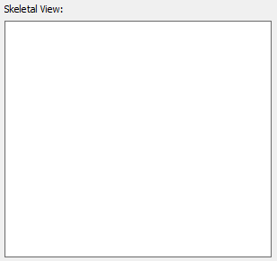

At first when the program starts (Assuming device is working correctly) this window will be black. However once the Kinect device recognises a person and starts capturing their movements a skeleton frame will appear here representing the data currently being captured.

## 5.3 Server interface

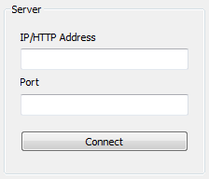

This is where all details required for the server connection can be entered. This program can connected to both IP/Port servers and HTTP servers. Once the details have been added simply select connect and the Kinect Client will attempt to establish a connection with the specified server.

## 5.4 Kinect interface

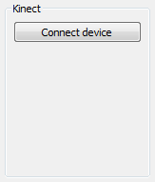

This area holds all options for the Kinect device itself. Currently there is only the option to connect a new device, this can be useful if you disconnect a device then attach a new one while the program is in operation.

## 5.5 Event log

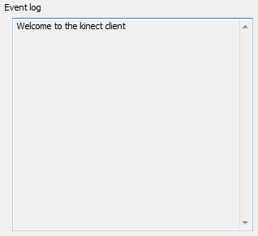

This is where all debug and event messages will be displayed. This is useful for knowing if the Kinect client is running successfully.